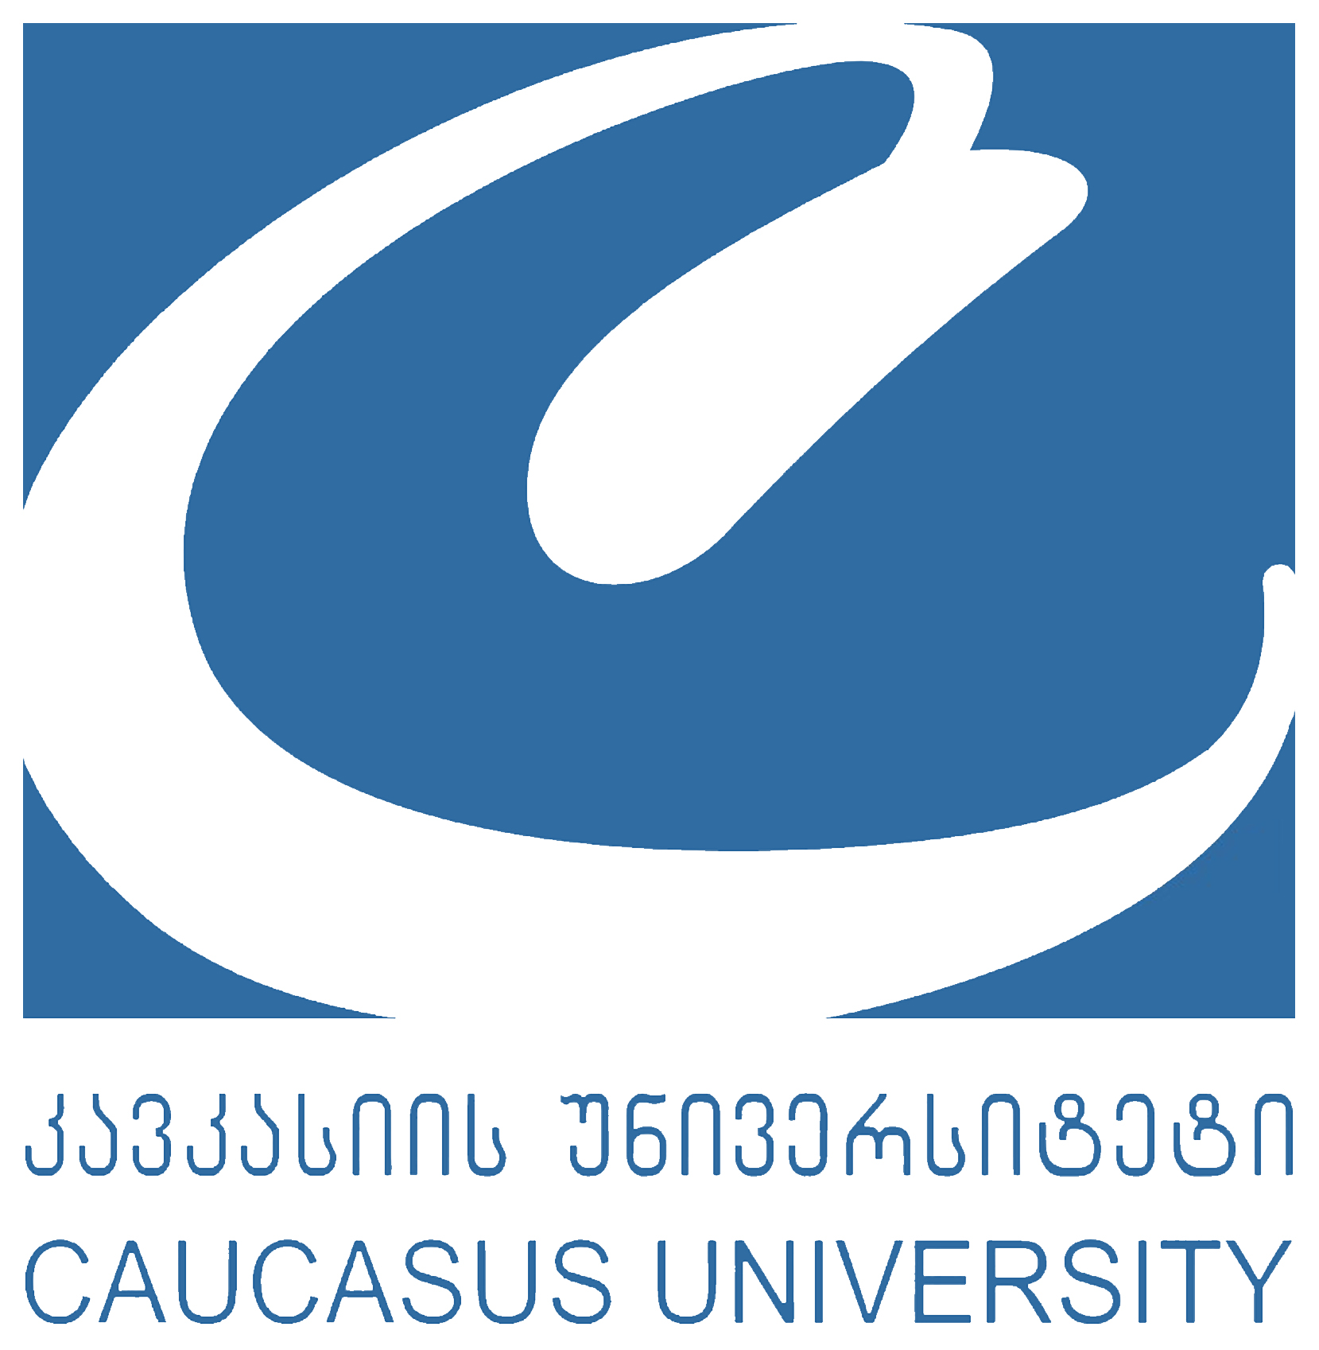

Student Application Form for the ERNST MACH Program
2023-2024 Academic Year

STUDENT’S PERSONAL DATA
(To be completed by the student applying)

Family name: | First name(s):
Sex: | E-mail address:
Date of Birth: | Tel:
Place of Birth: | Passport N. and date of issue / Personal ID number:
Current address:

STUDENT’S ACADEMIC DATA
Level of study | Bachelor: Master: PhD:
Sending School
Subject Area (Specialization)
Please indicate relevant semester for the mobility (2023 Fall or 2024 Spring)
GPA

LANGUAGE COMPETENCE
Mother tongue:

Language of instruction at home institution (if different):

Other Languages | Reading | Speaking | Writing | Listening
English
German
Other
Please indicate relevant level: Levels: A1/2 - Basic user, B1/2 - Independent user, C1/2 - Proficient

PREVIOUS STUDY ABROAD

Have you ever been an Exchange Student Before? Yes or No

If Yes, please indicate:

- Number of Months:
- Year of Mobility:
- Host University:

Level of Study: Bachelor Master PhD

Date:
Students Signature:

