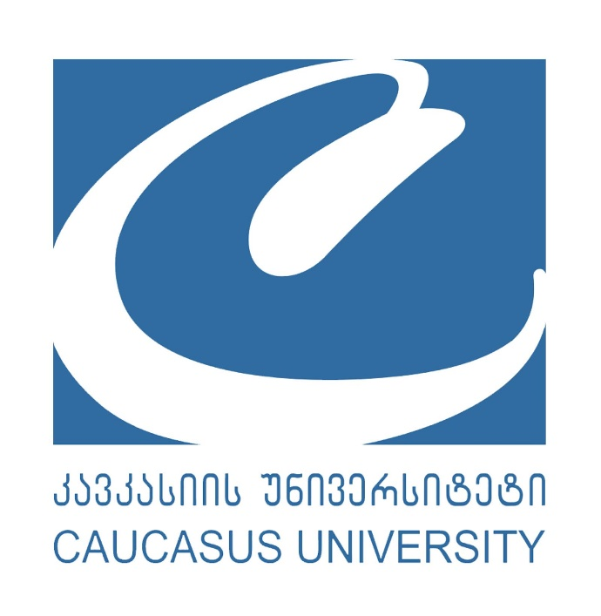

Caucasus University 10th Annual International Scientific Conference

“Digital World Evolution and Sustainable Development Goals: Transformation of Industries and Professions for Sustainable Development"

Application Form

Paper title

Author’s name

Co-author(s)’s names (if applicable)

Author’s affiliation (Department; University)

Affiliation of co-Author(s) (if applicable) (Department; University)
Author’s status | ☐ Professor  ☐ Associate Professor  ☐ Assistant Professor  ☐ Other (if yes, please specify)-------------------------------------  ☐ Ph.D. Candidate
Co-author’s status (if applicable) | ☐ Professor  ☐ Associate Professor  ☐ Assistant Professor  ☐ Other (if yes, please specify)-------------------------------------  ☐ Ph.D. Candidate

Abstract (max. 500 words including the background of the research topic, research questions, main objectives, methodology, and expected outcomes)

Scientific discipline

Keywords (max. 5)

Contact number

Author’s email address

Email address of the co-author(s)(if applicable)

Author’s LinkedIn (if applicable)

Co-author’s LinkedIn (if applicable)
How did you learn about the conference? | ☐ Caucasus University Website  ☐ Social media (LinkedIn, Facebook, X)  ☐ Other (if yes, please specify)-------------------------------------

Please send the filled form at research@cu.edu.ge

