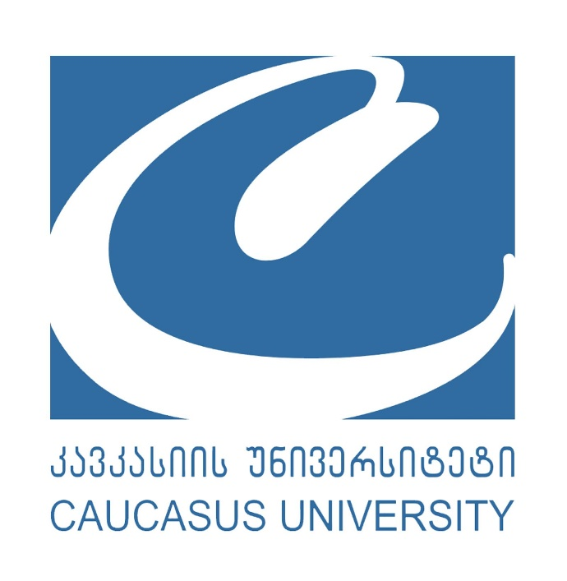

Caucasus University 10th Annual International Scientific Conference

“Digital World Evolution and Sustainable Development Goals: Transformation of Industries and Professions for Sustainable Development"
Registration form

Name and surname

Affiliation (university, organization, company, etc.)
Status | ☐ Professor  ☐ Associate Professor  ☐ Assistant Professor  ☐ Other (if yes, please specify)-------------------------------------  ☐ Ph.D. Candidate

Compose a cover letter, 300 words max., addressing these three points:

Why are you interested in this specific conference?

What do you expect to gain from your attendance?

How does the conference content and networking opportunities connect to your current job function and its objectives?

Contact number

Email address

LinkedIn (if applicable)
How did you learn about the conference? | ☐ Caucasus University Website  ☐ Social media (LinkedIn, Facebook, X)  ☐ Other (if yes, please specify)-------------------------------------

Please send the filled form to research@cu.edu.ge

