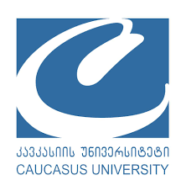
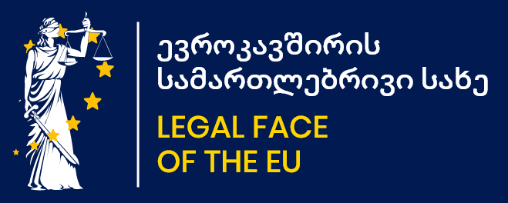

Jean Monnet Project “LFEU”

Law Trainings

Caucasus University, Sheraton Batumi Hotel

07-08 July,2021
Batumi, Adjara, Rustaveli str. 28
7 July
09.45 – 10.00 Registration
10.00 – 10.10 Opening. Information about the project, trainings, trainers and agenda
Project Coordinator Ms. Sophio Shengelia
10.10 – 10.15 Welcome Speech, Caucasus University President Mr. Kakha Shengelia
10.15 – 10.20 Welcome Speech, Batumi City Municipality Head, Mayor Mr. Archil Chikovani
10.20 – 10.25 Welcome Speech, Iv. Javakhishvili Tbilisi State University Rector,
Mr. Giorgi Sharvashidze
10.25 -10.55 European Integration Dynamic in Georgia, Ms. Eka Kardava
10.55 -11.45 European Union – goals, values, particular nature, Mrs. Guranda Chelide
11.45 – 12.00 Coffee-break
12. 00 – 13.30 EU law and Association Agreement, Ms. Eka Kardava
13.30 – 14.30 Dinner
14.30 – 16.15 Personal Data Protection Regulation in the EU, CoE and Georgia,
Mrs. Tamar Kaldani
16.15 - 16.30 Coffee-break
16.30 – 18.20 Association Agreement, EU labour directives and Georgian Labour Code,
Ms. Eka Kardava

8 July
09.45-10.00 Registration
10.00 – 11.45 Regulation of Cartels and State Aid in the EU and Georgia – Competition policy,
Mr. Solomon Menabdishvili
11.45 – 12.00 Coffee-break
12.00 – 13.30 State Procurement Regulation in the EU and Georgia, Mr. Levan Mosakhlishvili
13.30 – 14.30 Dinner
14.30 – 15.30 Thematic Questions to Trainers
15.30 – 16.30 Sum up/Resuming
16.30 – 17.00 Certificates, photos

Contact:
Maia Mushkudiani 599195956
Tako Gogaladze 555503350

